**Student Performance Analysis using MySQL**

**1. Introduction**

This project analyzes student performance using SQL queries. It ranks students based on total scores and calculates running totals for math scores.

**2. Dataset Setup**

**Create and Populate Students Table**

-- Use the database

USE mydb;

-- Drop table if it already exists

DROP TABLE IF EXISTS Students;

-- Create the Students table

CREATE TABLE Students (

StudentID INT PRIMARY KEY,

Name VARCHAR(100),

MathScore INT,

TotalScore INT

);

-- Insert sample data

INSERT INTO Students (StudentID, Name, MathScore, TotalScore) VALUES

(1, 'Alice', 85, 250),

(2, 'Bob', 90, 270),

(3, 'Charlie', 78, 220),

(4, 'David', 88, 260),

(5, 'Emma', 95, 280),

(6, 'Frank', 80, 230);

**3. Query Results**

**Task 1: Rank Students Based on Total Scores**

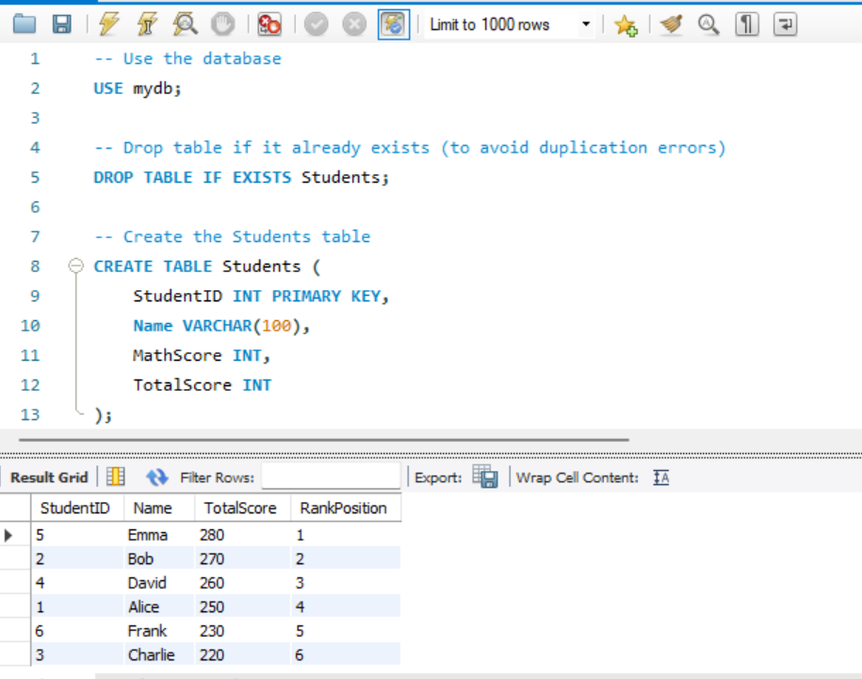

**Query Explanation:**

* Uses RANK() OVER (ORDER BY TotalScore DESC) to assign ranks.
* Students with the same score share the same rank.
* The next rank is skipped if a tie occurs.

**Task 2: Calculate Running Totals for Math Scores**

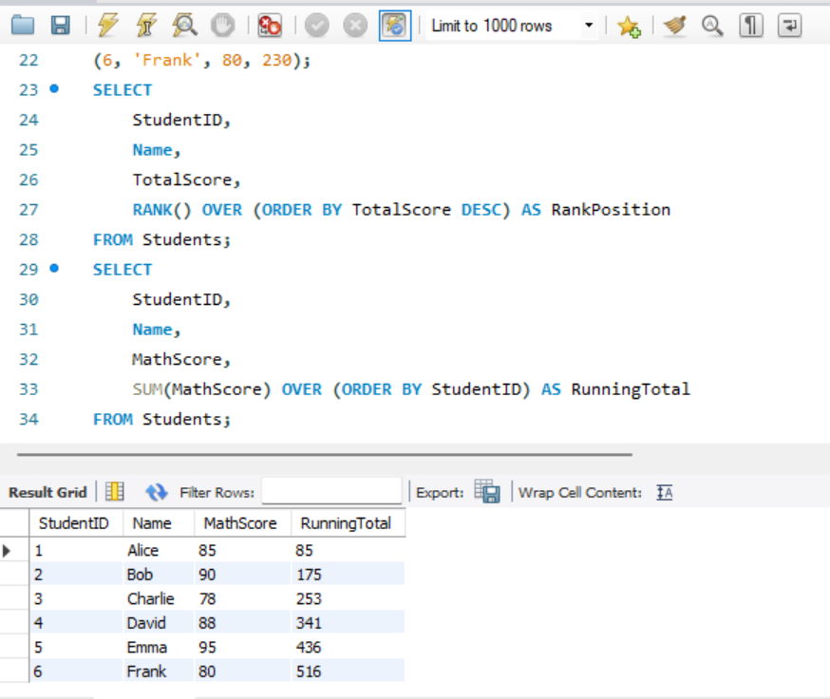

**Query Explanation:**

* Uses SUM(MathScore) OVER (ORDER BY StudentID) to compute cumulative totals.
* Running totals provide progressive aggregation of scores.

**4. Summary of Findings**

**Insights:**

* The ranking system effectively differentiates students based on total scores.
* The running total of math scores allows us to track cumulative progress.
* Students with higher math scores generally have higher total scores, indicating a strong correlation.

**5. How to Run the Queries**

1. Copy and paste the SQL scripts into **MySQL Workbench**.
2. Execute the queries step by step.
3. Analyze the output tables to verify ranking and running totals.